# Student Marks Report System

**1. Introduction**

The **Student Marks Report System** is a Java-based application developed using **Swing** for the GUI and **MySQL** for database management. This mini project enables users to enter student details and subject marks, generate a formatted report, calculate the percentage and grade, and store the data securely in a relational database.

**2. Objectives**

* To capture student details and subject-wise marks through a user-friendly interface.
* To calculate the total marks, percentage, and grade based on the input.
* To generate a clear and formatted student report.
* To store student records in a MySQL database for future reference.

**3. Tools and Technologies Used**

* **Programming Language:** Java
* **GUI Framework:** Java Swing
* **Database:** MySQL
* **IDE:** Eclipse / IntelliJ IDEA / NetBeans (any Java IDE can be used)
* **JDBC:** Java Database Connectivity for MySQL integration

**4. System Requirements**

* Java Development Kit (JDK 8 or above)
* MySQL Server
* MySQL JDBC Driver
* Java-supported IDE (like Eclipse or IntelliJ)

**5. Features**

* User-friendly GUI to enter student name, roll number, and marks.
* Input validation for empty fields, numeric marks, and range (0–100).
* Calculates:
  + Total Marks
  + Percentage
  + Grade (A, B, C, D, F)
* Displays report in a scrollable text area.
* Stores the student details and marks in a MySQL database.
* Prevents duplicate entries based on Roll Number using a UNIQUE constraint.
* Exit button to close the application.

**6. Database Design**

**Database Name:** studentdb  
**Table Name:** students

| **Field** | **Type** | **Description** |
| --- | --- | --- |
| id | INT | Auto-increment Primary Key |
| name | VARCHAR(100) | Student's Name |
| roll_no | VARCHAR(20) | Unique Roll Number |
| subject1 | INT | Marks in Mobile App Dev |
| subject2 | INT | Marks in Software Engineering |
| subject3 | INT | Marks in Artificial Intelligence |
| subject4 | INT | Marks in Digital Img Processing |
| subject5 | INT | Marks in Advanced DBMS |

**7. Functionality Description**

* On application start, a database table is created if it does not exist.
* User inputs:
  + Student Name
  + Roll Number
  + Marks in 5 subjects
* Upon clicking **Generate Report**:
  + Input validation is performed
  + Marks are saved into the MySQL database
  + Report is generated with:
    - Name, Roll Number
    - Marks in each subject
    - Total Marks
    - Percentage (calculated out of 500)
    - Grade (based on percentage thresholds)
* On clicking **Exit**, the application terminates.

**8. Code Structure:**

**File Name:** StudentMarksReport.java

**Main Components:**

* **Class:** StudentMarksReport – Inherits from JFrame and implements ActionListener.
* **Methods:**
  + initializeDatabase() – Creates the database table if it doesn't exist.
  + saveToDatabase() – Inserts student data and marks into the database.
  + generateReport() – Validates input, calculates total, percentage, grade, and generates the report.
  + showMessage() – Displays alerts using JOptionPane.
  + actionPerformed() – Handles button click events (Generate Report and Exit).
* **Main Method:**
  + Instantiates the StudentMarksReport class and launches the GUI.

**9. Grading Logic**

| **Percentage (%)** | **Grade** |
| --- | --- |
| 90–100 | A |
| 80–89 | B |
| 70–79 | C |
| 60–69 | D |
| Below 60 | F |

**10. Sample Output**

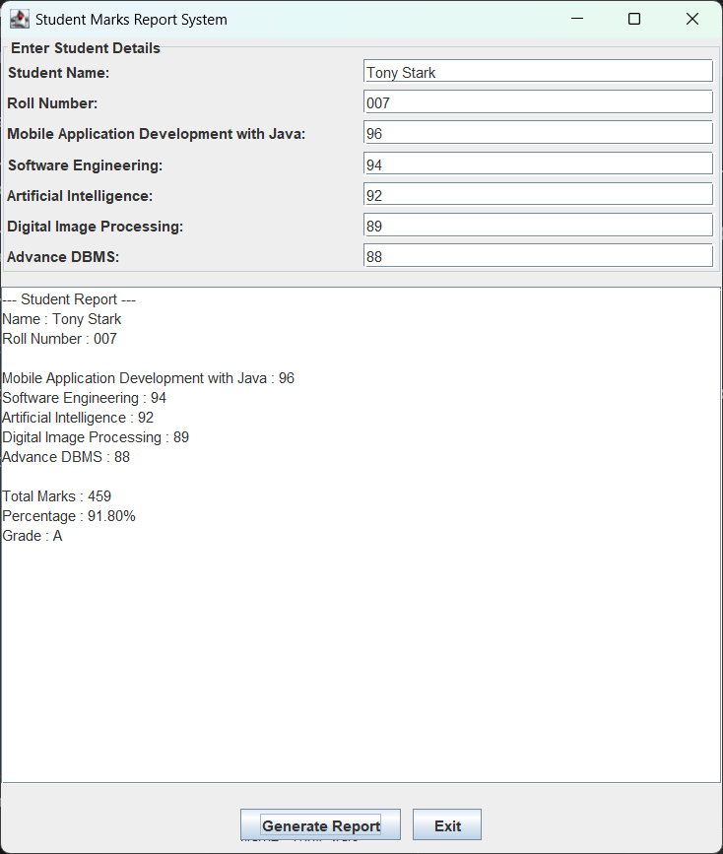

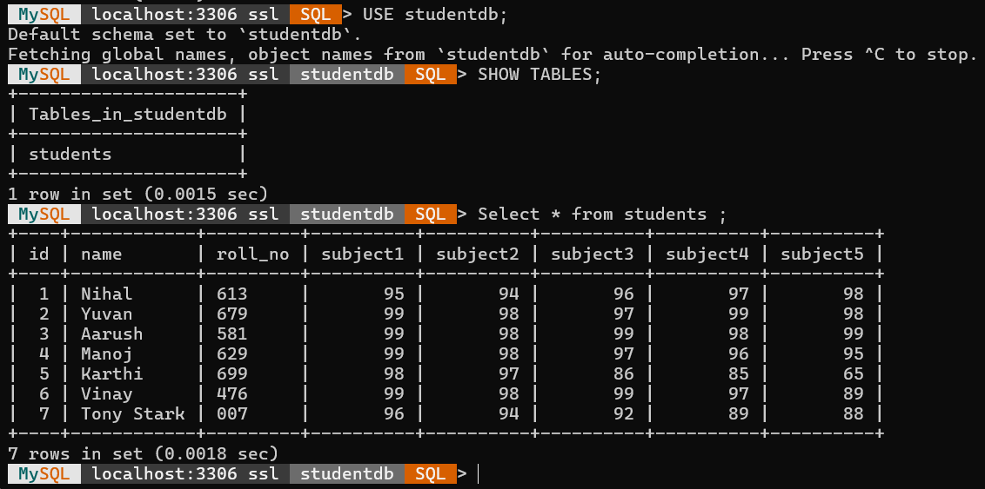

**11. Conclusion**

This project demonstrates the integration of Java Swing with a backend database using JDBC. It successfully fulfils the objective of generating a student marks report system with persistent data storage, validation, and formatted reporting. The modular code, clear GUI, and clean database design make it a simple yet effective educational project.

**12. Future Enhancements**

* Add update and delete functionality for records.
* Allow viewing all stored reports from the database.
* Include login functionality for teachers/admins.
* Export report to PDF or Excel format.
* Make the GUI responsive or web-based using JavaFX or Java Web frameworks.